Name:___________________________________________________

I’m walking round Evesham on Sunday 3rd September 2023 to raise funds for local charities and voluntary groups. Please see **https://walk.evesham.me** for more information.

Please complete the form below if you’d like to sponsor me. Many thanks!

|  |  |  |  |  |
| --- | --- | --- | --- | --- |
| Name Address | | Postcode | Amount (£) | Date received |
|  |  |  |  |  |
|  |  |  |  |  |
|  |  |  |  |  |
|  |  |  |  |  |
|  |  |  |  |  |
|  |  |  |  |  |
|  |  |  |  |  |
|  |  |  |  |  |
|  |  |  |  |  |
|  |  |  |  |  |
|  |  |  |  |  |
|  |  |  |  |  |
|  |  |  |  |  |
|  |  |  |  |  |
|  |  |  |  |  |
|  |  |  |  |  |
|  |  |  |  |  |
|  |  |  |  |  |
|  |  |  |  |  |
|  |  |  |  |  |
|  |  |  |  |  |
|  |  |  |  |  |
|  |  |  |  |  |
|  |  |  |  |  |

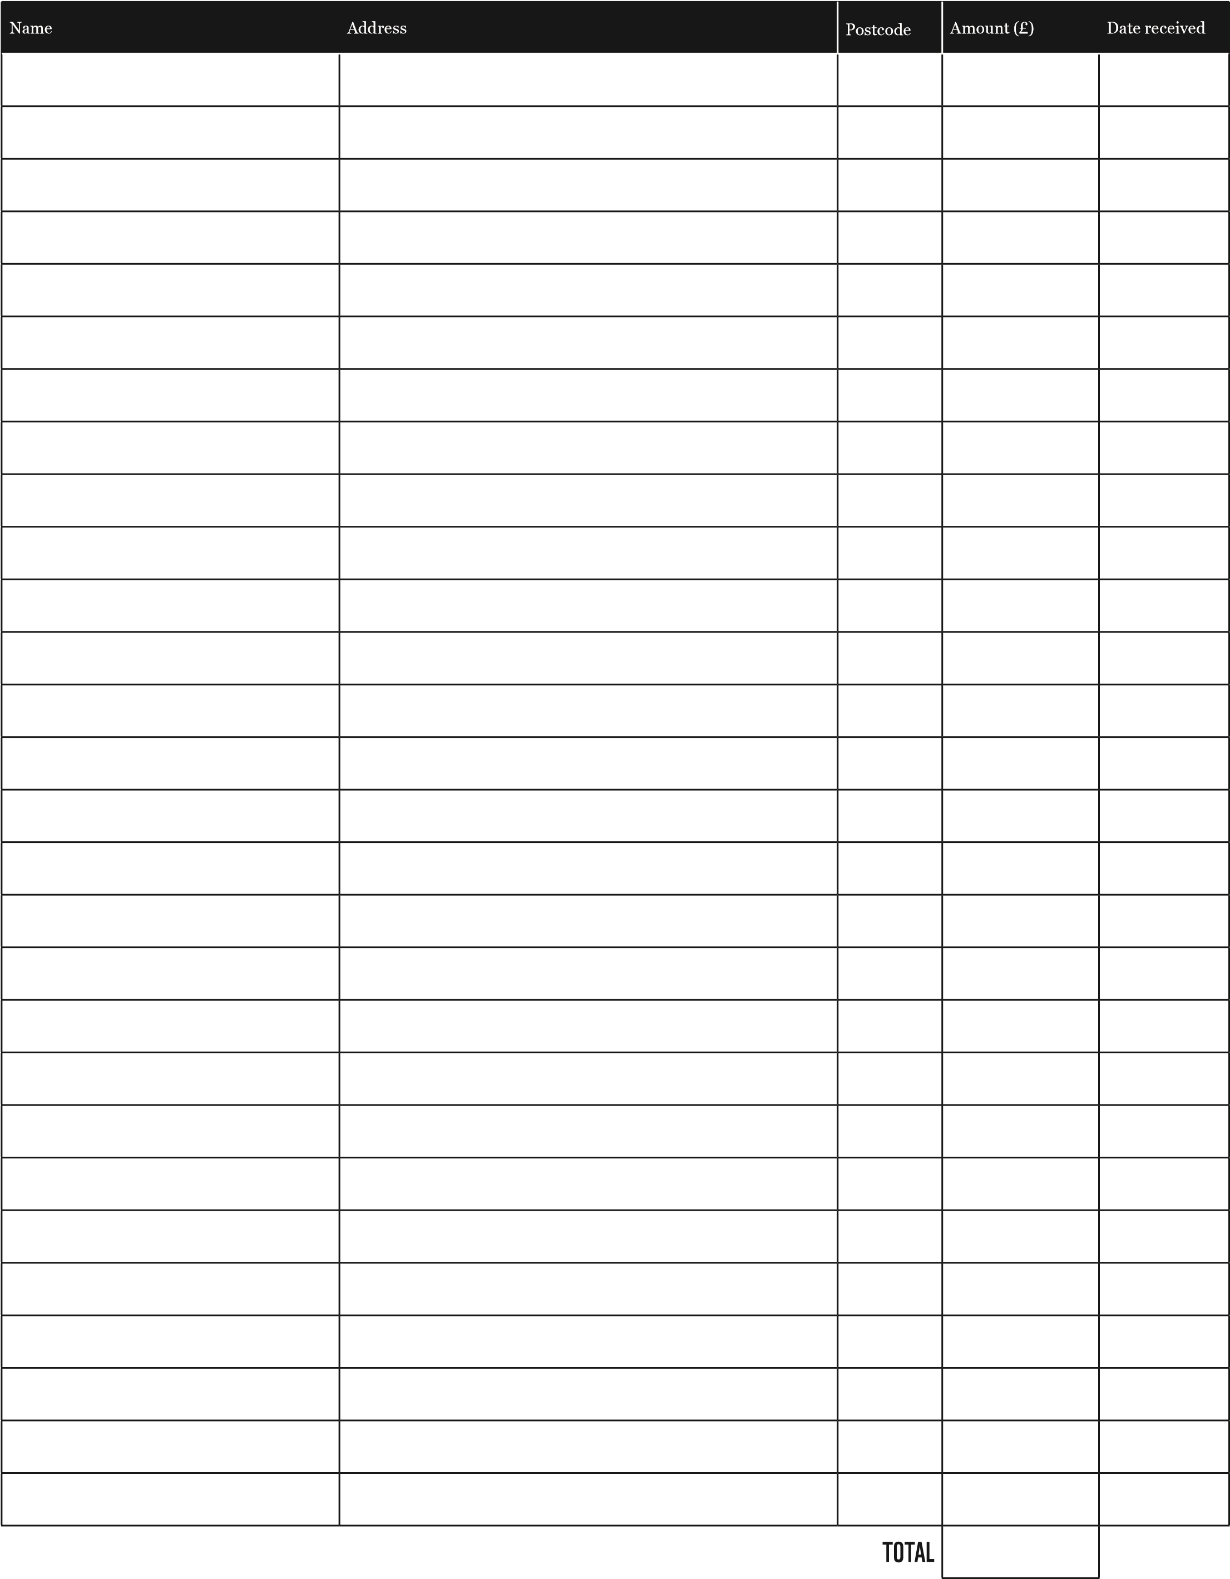

For more information or to download an additional form, please visit **walk.evesham.me.uk**